TYPESCRIPT
CHAPTER 1 – START HERE
TypeScript is compiled to Javascript and brings better tooling and strong typing
Requirements for typescript
- Text Editor Eg VSCode
- npm – make sure node is installed int the system
So for installation we gonna type npm i typescript -g for global

After then lets create a html file and a typescript file
So inside the typescript file we are Just gonna declare a variable and log to it and once we save it you can see we are writing javascript in a typescript file
So what we are going to do is enter the terminal and type the typescript command which is and then we name the typescript file which is main.ts and then the destination which is main.js
But if they have the same name we don’t really need to provide that name So
COMPILING TS to JS
tsc main.ts
And if we run it we are going to compile a javascript file named main.js
So now when we open it we can see its saying we have a problem here and also when declaring it has changed to var instead of let that’s because typescript can compile javascript to be compactible with order browsers and that’s something we will get into more as we cover the config file for our typescript
The error says cannot redeclare block-scoped variable ‘username’
That is because we have both of the files open which are main.ts and main.js and the same username is defined in both files
So if we close the JS file the error goes away
So lets link our JS file to the html and look to the console we will see the username is loged
Using the valid javascript which was compiled from our TypeScript

So if we make a change again in our TypeScript file we would have to recompile it again to JavaScript
But more easier way is to -w which will help us to keep watching after every change we make
So it will be tsc main.ts -w
So its going to recompile automatically
Note this is great if you just want to work with one file

So Now Lets structure if we want to have many files
First we gonna create a build and src folder
Build – Here there is our compiled code HTML,CSS AND JS
Src – Here is were we write our TS Code

SO HOW CAN WE MAKE TYPESCRIPT TO KNOW ALL OF TS FILES ARE IN THE SRC AND THEN COMPILE THEM AND PUT THEM NOT ONLY INTO BUILD BUT ALSO IN JS FOLDER INSIDE BUILD
So we can do this with a typescript config file
So TERMOINAL: tsc --init
So after then we will have tsconfig.json file
So in it we will first find the rootDir uncomment it and set it to be our source directory and after then we fint the outDir and set it to build and then inside js ./buid/js

So After then
TERMINAL: tsc -w
Here we don’t have to specify anyfile because it will just look for the all the files in the directory
So its like we are just telling typescript to start watching where we specified the root directory is

So after then notice it created the js directory in our build because it didn’t exist at first and it’s the path that we specified and then inside it created a main.js file

So if we create another file in src it will create them in JS to the build directory so its watching all the files not just one file
Note In the tsconfig file am also gonna comment the Other output options
// Other Outputs
"sourceMap": true,
"declaration": true,
"declarationMap": true,

To prevent other files from being created

So after we watch again notice that If we go to the main.js folder that is created it don’t use var like the first time it uses let like I have coded in main.ts file

So to fix that we can go to the tsconfig file and then change the target area
For now its written esnext but if you want a more order version of js so it can be compactible with order browsers you can maybe change it to es5
So after changing it it will immediately change in the main.js and start using var now
So it immediately recompiles based on those changes

Note if you delete a file from your TypeScript you will also need to Delete it in Your Javascript so it doesn’t Delete Automatically

So after then we need to Adjust Something a little bit
So we have set TypeScript to read the files in the src directory and be compiled to js in the js folder But what if we put the file in the root directory outside all the build and src directory it also compiles To js file in the same place
And that’s not right
So we don’t want it to happen we want it to ignore any typescript file which the src directory

So to set this lets go to the tsconfig file down and add
"include":[
"src"
]

So After then if we add any file outside the src directory will not be compiled

So Lets write Some more Code in main.ts
let username = "David Modestus Paul Mbwatila";
console.log(username);

let a = 12;
let b = '6';
let c = 2;

//CHAPTER 1 - START HERE
// // what we are suppose todo adding EXPLICIT TYPES
// let a: number = 12;
// let b: number = 6;
// let c: number = 2;

console.log(a / b);
// Here its not good in TS because it is static typed but in JS it could bring 2 because JS doesent mind the data coersion btn 12 and '6' which is a string
// So JS just corhesed the data into the type it wanted
//But for Typescript We can solve this in tsconfig by allowing noEmitOnError to true that any code that TypeScript doesent like will not be compiled
//You can also use the terminal when watching by typing tsc --noEmitOnError -w

console.log(c * b);

CHAPTER 2 – BASIC TYPES
TypeScript Terminologies
Strongly Typed Languages – Demand the specification of types - TS
Loosely Typed Language – Do not require type specification - JS
These relates to:
Static Typing
Dynamic Typing
-But its not the same because the programming language which is strongly typed can either be statically or dynamically typed

TS – is a statically typed language meaning types are checked at compile time
JS – is a dynamically typed language meaning types are checked at run time

TS Benefits
Self-documenting
Catch errors in dev
Reat for teams

Terminologies
Implicitly is when you don’t explicitly specify the datatype of the variable and TS implicitly gives it a type
Eg. let Name = “David”;
Explicitly when you specify the datatype of the variable
Eg. let Name: string = “David”;

Note
If you don’t specify the parameters in Functions TS Implicitly adds “any” type
A union type – You can assing the variable with two datatypes or more either is okay
Eg. let myStatus: string | number;

CHAPTER 3 – ARRAYS & OBJECTS
If you don’t specify the datatype in array TS infers what is in or the union which is in
The empty array is TS infers any datatype Eg. let test = []
Note: let guitar : (string | number)[] is equal to let stringArr :string[] - TS Accepts
BUT
let stringArr :string[] is NOT equal to let guitar : (string | number)[] - TS Doesn’t Accept
This is because guitar accepts string and number but stringArr only accepts string

NOTE
The Order of the types in the Array does not matter but of you want to be more strict about the order and specific element type you gonna use a Tuple
Eg.
let myTuple: [string, number, boolean] = ["dave", 42, true];

And here comparison btn a Tuple with a normal array
The array is equal to tuple because it consists of string number and Boolean
But the tuple is not equal to the array because it is required to have string number and Boolean in a specific order and items cannot be assigned fewer
let myTuple: [string, number, boolean] = ["dave", 42, true];

let mixed = ["james",43,false]

mixed = myTuple
But
myTuple != mixed

Objects
//Objects
let myObject: object;
myObject = [];
console.log(typeof myObject);

myObject = bands;
myObject = {};

Here first we anetate myObject that its an object and then we assing it to an array because an array its also the type of an object and then we log to the type of myObject we get object
And Also we can assign it to bands and {}

const exampleObj = {
prop1: "Dave",
prop2: true,
};

And here we just made an object and typescript just implicitly assigned prop1 to be string and prop2 to be Boolean

So if we need to define our types for our object we can use types OR interface
Example:
type Guitarist = {
name: string;
active: boolean;
album: (string | number)[];
};

let evh: Guitarist = {
name: "David",
active: true,
album: ["Iaefsel", "David.dev", 45],
};

let JP: Guitarist = {
name: "Jimmy",
active: false,
album: [2817, "Jimmy47", 45],
};

console.log(evh,JP)

First we defined the types and then we just let evh and we say this is type Guitarist and then we enter the values Same as with JP
In INTERFACE you can type
interface Guitarist{
name: string;
active: boolean;
album: (string | number)[];
};

Note:
We cant just add another type to JP or evh which is not predefined in Guitarist type
Also adding “ ? “ before the colon to the type which we pre defined makes it optional by making it union with undefined Eg. active?: boolean;
So now that active its optional you can remove it if you want

When Do I use INTERFACE and TYPE
We will discuss later but interface has something to deal with a class

ENUMS

//********Enums ********/
// Unlike most typescript features, Enums are not a type level addition to Javascript but something
//Added to the language and runtime
enum Grade{
U = 2,
D,
C,
B,
A
}
console.log(Grade.U)
//So in enum they are enumerated from zero 0
//And if you want to change them you can just assing to the number you want and those following will adopt

// SO HERE WE HAVE COVERED ARRAYS, TUPLES, OBJECT AND ENUMS

// SO HERE WE HAVE COVERED ARRAYS, TUPLES, OBJECT AND ENUMS

CHAPTER 4 – FUNCTIONS

CHAPTER 5 – ASSERTIONS
Type assertion and Type casting are often used interchangeably on the web but most of the courses only chooses one world
What is TYPE ASSERTIONS
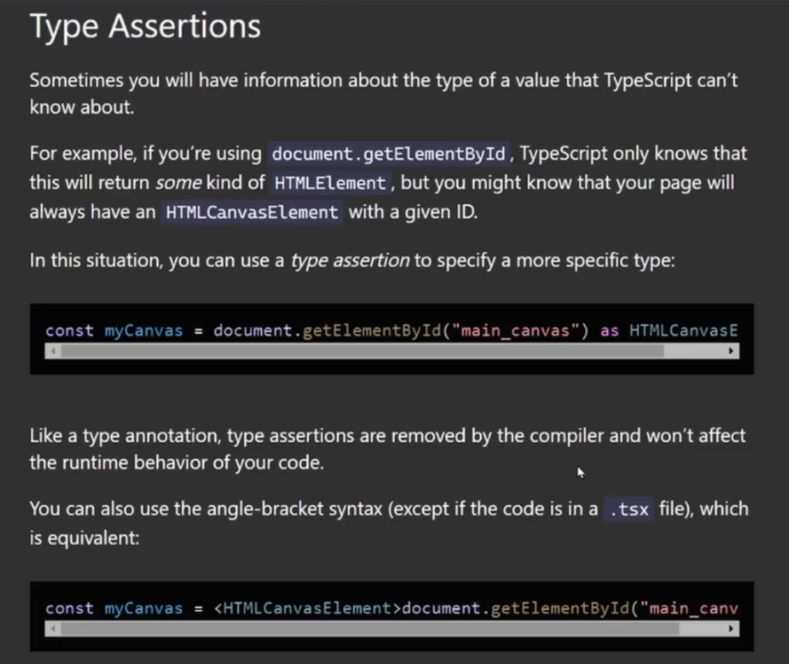
CHAPTER 6 – CLASSES

CHAPTER 7 – Index Signatures & Keyof Assertions

CHAPTER 8 – GENERICS

CHAPTER 9 – UTILITY TYPES

CHAPTER 10 – VITE
Whats new in the Folder Structure –
1.vite-env.d.ts file here we will be able to set the types
For our environment variables
2.tsconfig.json
3.tsconfig.node.js
Note:
Vite Shows Deployment GUIDELINES VERY EASY STEP BY STEP
Also Environment Variables and Modes

CHAPTER 11 – TS with REACT

CHAPTER 12 – HOOKS

CHAPTER13– useReducer

CHAPTER14– useContext

